Ideation Phase
Define the Problem Statements

Date | 30 October 2025
Team ID | NM2025TMID01741
Project Name | Calculating Family Expenses Using ServiceNow
Maximum Marks | 2 Marks

Customer Problem Statement Template
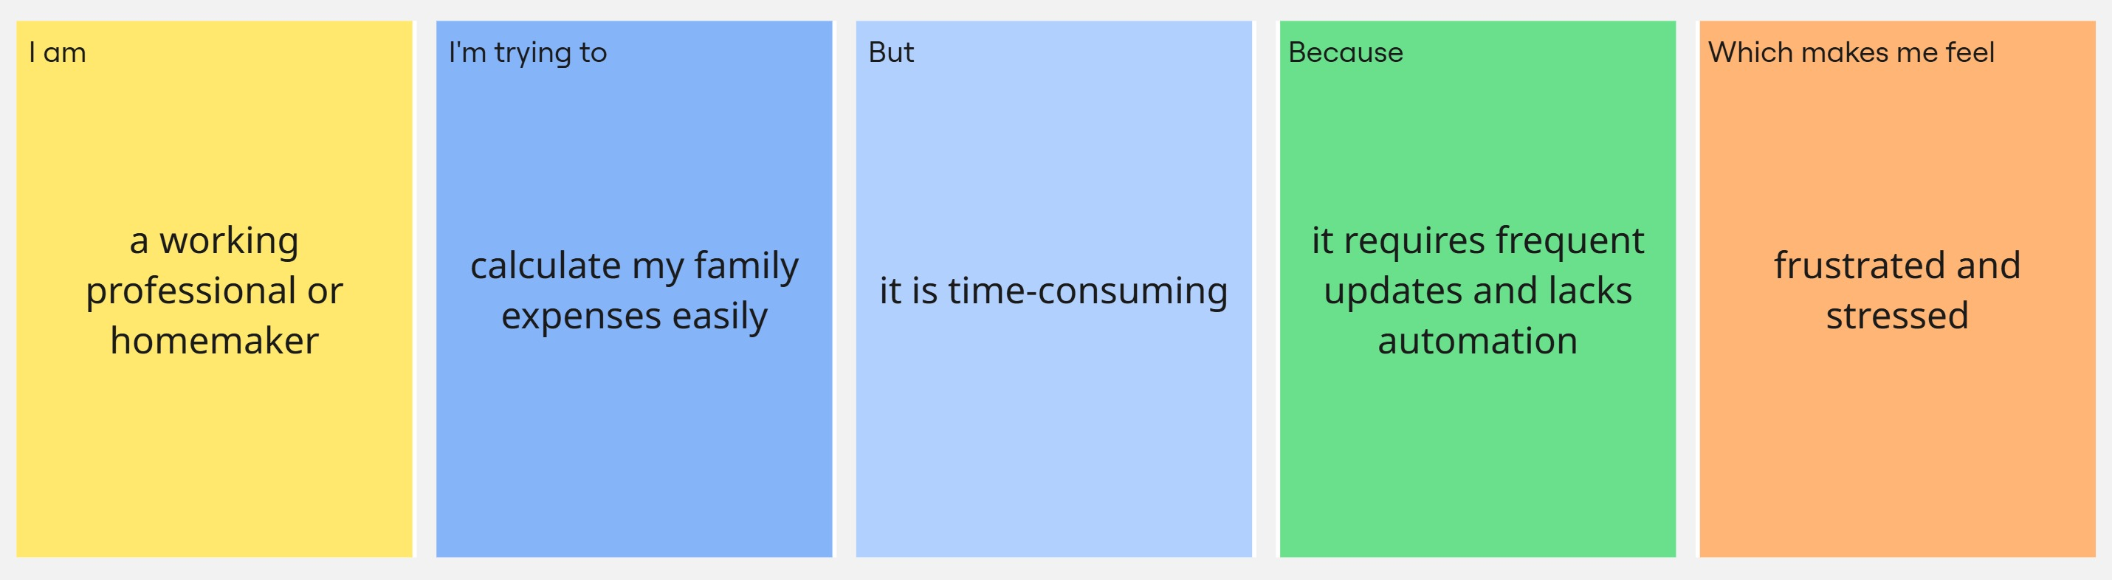

Problem Statement Table
Problem Statement (PS) | I am (Customer) | I’m trying to | But | Because | Which makes me feel
PS-1 | a working professional or homemaker managing my family’s monthly budget | track and record daily, weekly, and monthly family expenses easily | manual tracking using notebooks or spreadsheets is time-consuming | it requires frequent updates, calculations, and lacks automation | frustrated and stressed about losing control over my family’s spending
PS-2 | a user who wants to improve financial planning | analyze spending patterns and generate reports automatically | there is no centralized platform to visualize and analyze expenses | traditional methods do not provide real-time insights or automated reports | uncertain about my financial status and future savings

